**EECS 360**

**Lab 11**

**11/8/16**

**Chen Long**

1. **Objective**

This lab is about how sampling frequency will affect the Fourier Transform, which we will be focusing on aliasing on this lab.

1. **Description**

We will pick three sampling period, which are 1000 samples/s, 100 samples/s, 20 samples/s, 10 samples/s. We will use cosine equation for part 1, and we will do fft in figure 2.

1. **Result**

As what we expect, in part 1, the result of sample rate of 100 is the same as the result of 1000 samples/s. However, when we drop the sample rate to 20 samples/s, we start to loss information, it is because the sampling frequency is lower than the Nyquist rate. It’s also obvious to check it in the fft graph, because we can see the gap between each sample as when the sample frequency goes down.

1. **Result**

This lab is a knowledge of enhancement of the previous lab, what we did on the previous lab is about sampling by time, this lab is sampling by frequency, however, they are mostly the same but slightly different concept, since T=1/f, therefore we can still derive frequency to time and do the same thing as last lab.

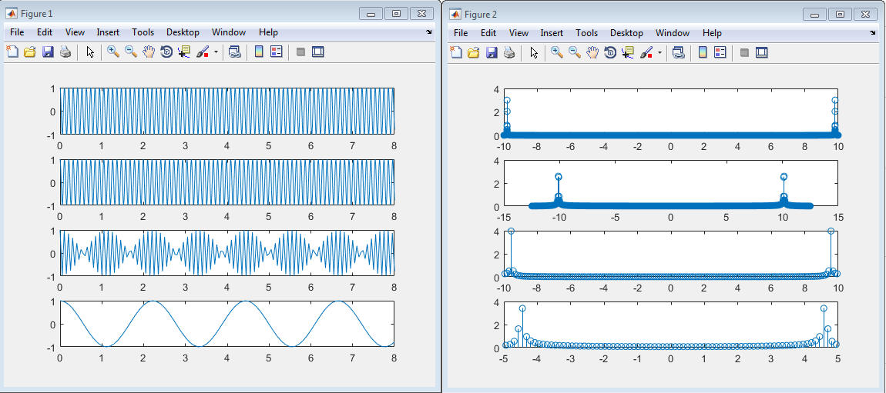

**MATLAB CODE**

clear all;

% part 1

% 1000 samples

figure (1);

fs1=1000;

Ts1=1/fs1;

n1=0:Ts1:8;

x=cos(60*n1);

subplot(411);

plot(n1,x);

% fft

figure(2);

y=abs(fft(x))/fs1;

f=(-(length(y)-1)/2:(length(y)-1)/2)*20/length(y);

subplot(411);

stem(f,y);

% 100 samples

figure (1);

fs1=100;

Ts1=1/fs1;

n1=0:Ts1:8;

x=cos(60*n1);

subplot(412);

plot(n1,x);

% fft

figure(2);

y=abs(fft(x))/fs1;

f=((-(length(y)-1)/2):((length(y)-1)/2))*25/length(y);

subplot(412);

stem(f,y);

% 20 samples

figure (1);

fs1=20;

Ts1=1/fs1;

n1=0:Ts1:8;

x=cos(60*n1);

subplot(413);

plot(n1,x);

% fft

figure(2);

y=abs(fftshift(fft(x)))/fs1;

f=((-(length(y)-1)/2):((length(y)-1)/2))*20/length(y);

subplot(413);

stem(f,y);

% 10 samples

figure (1);

fs1=10;

Ts1=1/fs1;

n1=0:Ts1:8;

x=cos(60*n1);

subplot(414);

plot(n1,x);

% fft

figure(2);

y=abs(fft(x))/fs1;

f=(-(length(y)-1)/2:(length(y)-1)/2)*10/length(y);

subplot(414);

stem(f,y);